ABC TITLE

A RESEARCH THESIS
Submitted to the Board of Advanced Studies and Research
Dow University of Health Sciences In partial fulfillment of the Requirement
for the degree of
DOCTOR OF MEDICINE
Insert your Institute Monogram

(PULMONOLOGY)



By
DR. ABC
Department of Oral Biology (Specify the department except MD/MS students)
School of Postgraduate Studies
Dow University of Health Sciences
Karachi, Pakistan
July 2021

DEDICATION

I dedicate my work to…..

My late parents, for their unconditional love, untiring efforts and constant prayers for making me what I am today…………

ACKNOWLEDGEMENTS

I thank my Allah for his blessings and support so that I could complete my work amicably.
When I write this acknowledgement, a lot of names keep on pouring into my mind who have made my otherwise tedious journey easier.
I would like to start with late Dr. ABC who has always guided and supported me. ……………

DECLARATION

I _____________________________________________________hereby state that my Master’s thesis titled________________________________________________________________________________________________________________________________________________is my own work and has not been submitted previously by me for taking any degree from Dow University of Health Sciences or anywhere else in the country/world.
At any time if my statement is found to be incorrect even after my Graduate the university has the right to withdraw my MPH/MSPH/M.Sc DS/MSBE/ MSAPT/MSN/MDS/MPhil degree.

Student Name
MPhil Trainee
Subject: Pharmacology
Institute of Biomedical Sciences
Dow University of Health Sciences
Signature_________________________________
Enrolment No. 07/2005/003
Date: 2nd July 2021
CERTIFICATE

This is to certify that the thesis entitled “ABC Title” submitted by Dr. ABC to the Institute of Clinical Sciences, Dow University of Health Sciences, Karachi for the award of the degree of Doctor of Medicine (Pulmonology), is a bonafide record of the research work carried out by him under my supervision and guidance. The content of the thesis, in full or parts have not been submitted to any other Institute or University for the award of any other degree or diploma.
Supervisor:

Dr. ABC,
Qualification
Designation
Department name
Institute of Health Management,
DUHS, Karachi

CERTIFICATE

This is to certify that the thesis entitled “ABC Title” submitted by Dr. ABC to the Institute of Clinical Sciences, Dow University of Health Sciences, Karachi for the award of the degree of Doctor of Medicine (Pulmonology), is a bonafide record of the research work carried out by him under my supervision and guidance. The content of the thesis, in full or parts have not been submitted to any other Institute or University for the award of any other degree or diploma.
Co-Supervisor (If any):

Dr. ABC,
Qualification
Designation
Department name
Institute of Health Management,
DUHS, Karachi

CERTIFICATE

This is to certify that the thesis entitled “ABC Title” submitted by Dr. ABC to the Institute of Clinical Sciences, Dow University of Health Sciences, Karachi for the award of the degree of Doctor of Medicine (Pulmonology), is a bonafide record of the research work carried out by him under my supervision and guidance. The content of the thesis, in full or parts have not been submitted to any other Institute or University for the award of any other degree or diploma.
Clinical Supervisor (If Any):

Dr. ABC,
Qualification
Designation
Department name
Institute of Health Management,
DUHS, Karachi

CERTIFICATE

This is to certify that the thesis entitled “ABC Title” submitted by Dr. ABC to the Institute of Clinical Sciences, Dow University of Health Sciences, Karachi for the award of the degree of Doctor of Medicine (Pulmonology), is a bonafide record of the research work carried out by his/her under supervision and guidance of assigned supervisors. The content of the thesis, in full or parts have not been submitted to any other Institute or University for the award of any other degree or diploma.
MD Program Director:

Dr. ABC,
Qualification
Designation
Department name
Institute of Health Management,
DUHS, Karachi

TABLE OF CONTENTS
ABSTRACT i
Background i
Objectives i
Methods i
Results i
Conclusion i
CHAPTER 1 1
1. INTRODUCTION 1
1.1. Background 1
1.2. Significance of the problem 1
1.3. Objective of the study 1
1.4. Hypothesis 1
1.5. Operational Definitions 1
CHAPTER 2 2
2. Review of Literature 2
CHAPTER 3 3
3. Methodology 3
3.1. Study Design 3
3.2. Study Population/Settings 3
3.3. Sampling Technique 3
3.4. Sample Size 3
3.5. Study Duration From date to date 3
3.6. Inclusion Criteria 3
3.7. Exclusion Criteria 3
3.8. Study Parameters 3
3.9. Ethical Considerations 3
3.10. Data Collection Procedure 3
3.11. Data Analysis Procedure 3
CHAPTER 4 4
4. Results 4
4.1. Frequency of Pharma 4
4.2. ABC 5
4.3. XYZ 5
CHAPTER 5 8
5 DISCUSSION 8
5.1. Limitations 8
5.2. Strength of Study 8
5.3. Weakness of Study 8
5.4. Conclusion 8
5.5. Recommendations 8
REFERENCES 9
Appendix-I PROFORMA 10
Appendix-I Scientific Committee Approval 11
Appendix-II BASR Approval Letter 12
Appendix-III IRB Approval Letter 13
Appendix-IV Plagiarism Undertaking 14
Appendix-V Turnitin Digital Receipt 15
Appendix-VI Summary of the Similarity Index (Plagiarism) 16
Appendix-VII 17

LIST OF TABLES (if Any)
Table 4. 1 Frequency of Pharma 12
Table 4. 2 ABC 12
Table 4. 3 XYZ 12

LIST OF FIGURES (if Any)
Figure 4. 1 DEF 13
Figure 4. 2 GHI 13
Figure 4. 3 JKL 14
Figure 4. 4 14

LIST OF SYMBOLS (if Any)

LIST OF ABBREVIATIONS (if Any should be in ascending order)

CHK Civil Hospital Karachi
COPD Chronic obstructive pulmonary Disease
DMC Dow Medical College
WHO World Health Organization

ABSTRACT

Background:
Objectives:
Methods:
Results:
Conclusion:

Key Words: Anthracosis, histomorphology, etc..

CHAPTER 1

INTRODUCTION
In this chapter, clearly state what the purpose of the study is and explain the study's significance. The significance is addressed by discussing how the study adds to the theoretical body of knowledge in the field and the study's practical significance for communication professionals in the field being examined.
Ph.D. students also must explain how their research makes an original contribution to the body of knowledge in their discipline. They also should address the significance of the study for mass communication education.
Before writing introduction in the thesis, the student should study relevant literature retrieved from published papers. Relevant articles are selected, which improve the understanding of the topic. Only pertinent references are cited but not extensively reviewed in this section. Rationale of the study should be mentioned at the end of introduction. The word count of Introduction section should be a minimum of 1000.

Background

Significance of the problem

Objective of the study

Hypothesis

Operational Definitions

Management
    - Non-operative
    - Operative

CHAPTER 2

Review of Literature
The purpose of the study should suggest some theoretical framework to be explained further in this chapter. The literature review thus describes and analyzes previous research on the topic.
This chapter, however, should not merely string together what other researchers have found. Rather, the scholar should discuss and analyze the body of knowledge with the goal of determining what is known and is not known about the topic. This determination leads to your research questions and/or hypotheses. In some cases, of course, you may determine that replicating previous research is needed. It should be a collective review and critique in the candidate's own words of various viewpoints supported by relevant data, and should not be copied from published work. The review should be properly referenced. References should preferably be of the last 15 years, including some published in the recent past. However, older references can be cited provided they are relevant and historical.
It is essential to also include a review of the local literature. A special effort should be made to collect and review all work done in Pakistan on the chosen topic. This should include work published in recognized journals and in publications of various societies and medical colleges, as well as abstracts of meetings, conferences or seminars held in Pakistan or abroad. Data collected by others, whether published or unpublished, must be acknowledged whenever included.

CHAPTER 3

Methodology
In this section, the scholar must not refrain from the methodology which was approved by the BASR of DUHS. Any additional information which the scholar needs to share with the assessor / evaluator can be added in the methodology section. Past tense should be used here since the research will reflect the project is undertaken in the past.
In this section, the following sequence of headings must be used;

Study Design

Study Population/Settings

Sampling Technique

Sample Size

Study Duration From date to date

Inclusion Criteria

Exclusion Criteria

Study Parameters

Ethical Considerations

Data Collection Procedure

Data Analysis Procedure
“In this section you have to write about which statistical model / technique (Test) you have applied and your data follows normal distribution or not.
For inter group comparison / association which post-hoc or parametric / non-parametric test you have applied.
How did you present your work in Chapter 4 results section whether made chart/figures or Frequency tables, or Mean, Standard deviation, Confidence Interval?”

CHAPTER 4

RESULTS
This chapter addresses the results from your data analysis only. This chapter does not include discussing other research literature or the implications of your findings.
Usually you begin by outlining any descriptive or exploratory/confirmatory analyses (e.g., reliability tests, factor analysis) that were conducted. You next address the results of the tests of hypotheses. You then discuss any ex post facto analysis. Tables and/or figures should be used to illustrate and summarize all numeric information.
For qualitative and historical research, this chapter usually is organized by the themes or categories uncovered in your research. If you have conducted focus groups or interviews, it is often appropriate to provide a brief descriptive (e.g., demographic) profile of the participants first. Direct quotation and paraphrasing of data from focus groups, interviews, or historical artifacts then are used to support the generalizations made. In some cases, this analysis also includes information from field notes or other interpretative data (e.g., life history information).
The purpose of this chapter is not just to reiterate what you found but rather to discuss what your findings mean in relation to the theoretical body of knowledge on the topic and your profession. Typically, students skimp on this chapter even though it may be the most important one because it answers the "So what?" question.
Begin by discussing your findings in relation to the theoretical framework introduced in the literature review. In some cases, you may need to introduce new literature (particularly with qualitative research).
This chapter also should address what your findings mean for communication professionals in the field being examined. In other words, what are the study's practical implications?
Doctoral students also should discuss the pedagogical implications of the study. What does the study suggest for mass communication education?
This chapter next outlines the limitations of the study. Areas for future research then are proposed.

Frequency of Pharma
Video provides a powerful way to help you prove your point. When you click Online Video, you can paste in the embed code for the video you want to add. You can also type a keyword to search online for the video that best fits your document.

Table 4. 1 Frequency of Pharma
 | D | F
A | 54 | 65
C | 12 | 32

ABC
Video provides a powerful way to help you prove your point. When you click Online Video, you can paste in the embed code for the video you want to add. You can also type a keyword to search online for the video that best fits your document.
Table 4. 2 ABC
 | D | F
A | 54 | 65
C | 12 | 32

XYZ
Video provides a powerful way to help you prove your point. When you click Online Video, you can paste in the embed code for the video you want to add. You can also type a keyword
Table 4. 3 XYZ
 | D | F
A | 54 | 65
C | 12 | 32

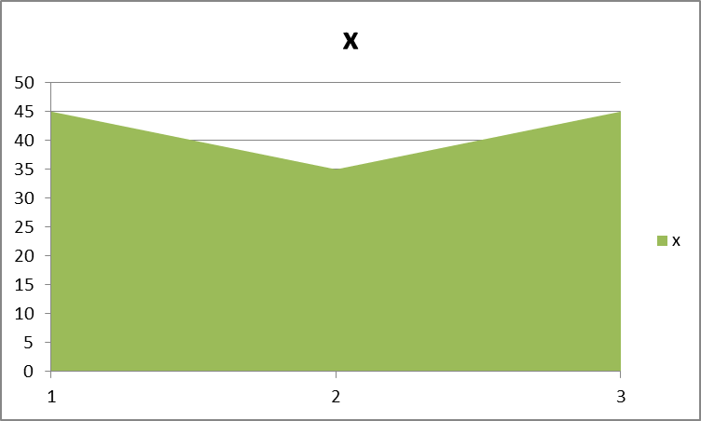
Figure 4. 1 DEF

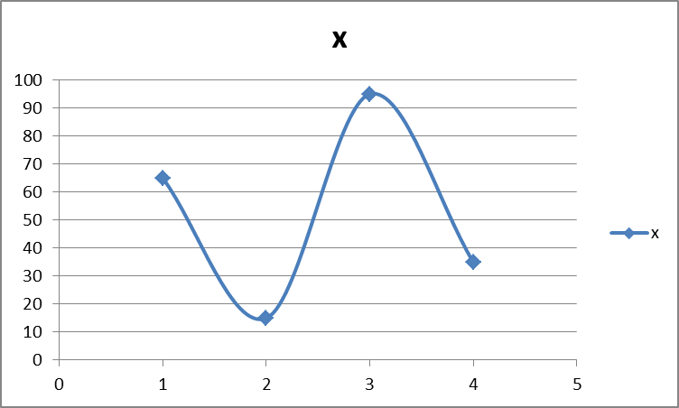
Figure 4. 2 GHI

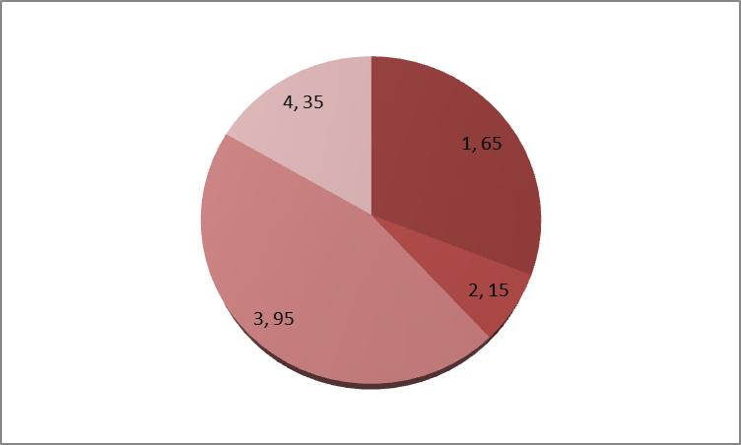
Figure 4. 3 JKL

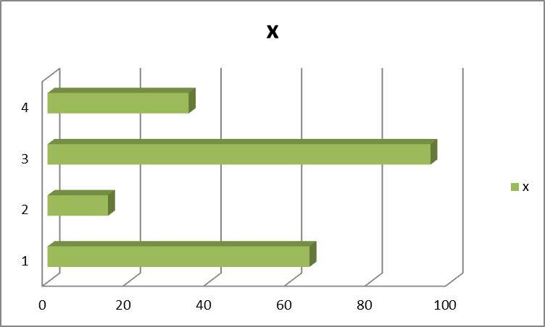
Figure 4. 4

CHAPTER 5

DISCUSSION
The purpose of this chapter is not just to reiterate what you found but rather to discuss what your findings mean in relation to the theoretical body of knowledge on the topic and your profession. Typically, students skimp on this chapter even though it may be the most important one because it answers the "So what?" question.
Begin by discussing your findings in relation to the theoretical framework introduced in the literature review. In some cases, you may need to introduce new literature (particularly with qualitative research).
This chapter also should address what your findings mean for communication professionals in the field being examined. In other words, what are the study's practical implications?
Doctoral students also should discuss the pedagogical implications of the study. What does the study suggest for mass communication education?
This chapter next outlines the limitations of the study. Areas for future research then are proposed.

Limitations

Strength of Study

Weakness of Study

Conclusion

Recommendations
Recommendations for further research may be included when appropriate It is important to be careful that the conclusions should not go beyond data and should be based on the study results and population.

REFERENCES
The references should be writing in Vancover Style. (Suggest to use Endnote).

- Mostafa Q Orbani, Masud Yunesian, Hamid Reza Baradaran. Indoor Smoke Exposure and Risk of Anthracosis. Iran J Med Sci 2014 Nov;39(6):571-76.

Appendix-I PROFORMA

Appendix-I Synopsis Approval from Scientific Committee

Appendix-III Synopsis Approval from IRB

Appendix-IV Synopsis Approval from BASR

Appendix-V Plagiarism Undertaking

Download the uploaded template and print on legal stamp paper of Rs. 100.

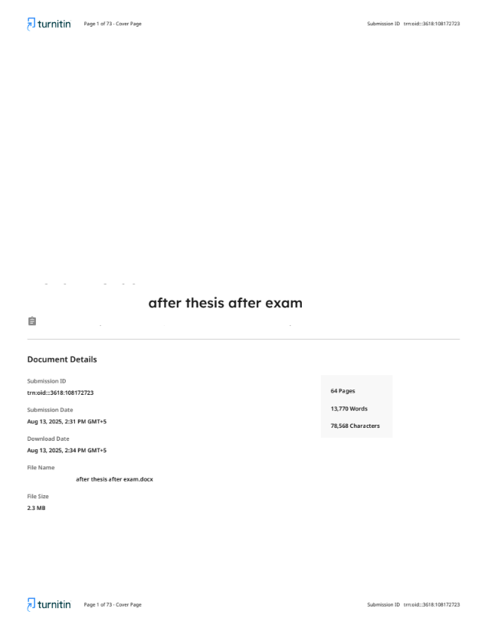
Appendix-VI: Turnitin Cover Letter

Appendix-VIIa Summary of the Similarity Index
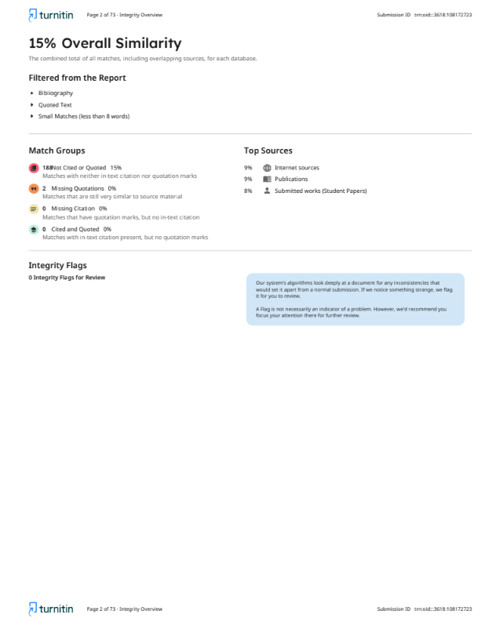
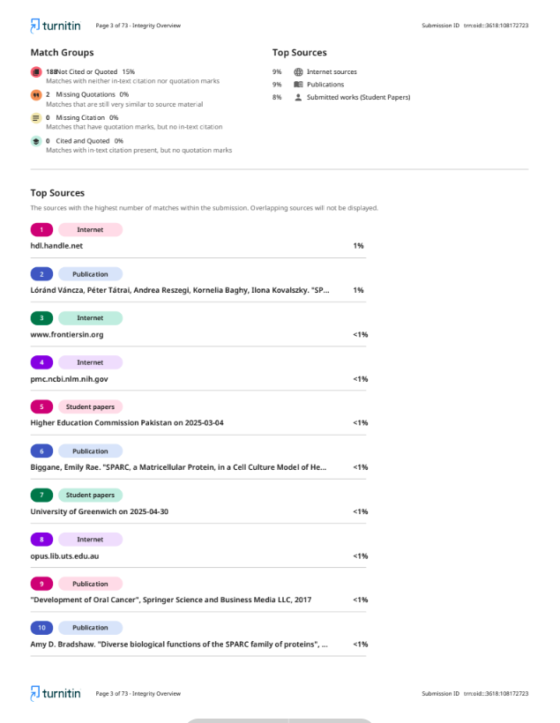
Appendix-VIIb Summary of the Similarity Index
Appendix-VIII
Etc….

