Enchantress
  - Feel the beauty

Business plan
Company name: Enchantress

Instagram shop: enchantress_pk
Postal address: Karachi, Pakistan, 75330
Email address: enchantresspk6@gmail.com
Business phone: 03372115646
Business owner: Masooma Hashim
Department: Institute of Business Health Management, DUHS.
Table of Contents

I. Executive Summary………………………….………………..3
II.Company Description ………………….…………………..4
III. Product & Service Description …………….………………..7
IV. Marketing Plan ………………...…………….…………….13
V.SWOT Analysis………………………………………………14
VI. Competitor Data Collection Plan ………….…………...15
VII.Competitive Analysis……………………….………………15
VIII.Marketing Expenses Strategy Chart………………………..17
IX. Operational Plan ……………………………………………..17
X Financial Plan ……………………………………………..18

- Executive Summary
Overview:
‘Enchantress’ was established in the year 2021 and is providing handmade best-chosen resin items including Pendants, Earrings, tote bags, keychains and paintings that are decorated with innovative and trendy designs and high-quality packaging with smooth and hassle-free delivery.
Goals for the Business:
My business is small scale but I see myself growing in upcoming years by adding more product lines targeting the same audience of women.
My Management Team:
My business is a sole proprietorship and I'm the one and the only person who works on product manufacturing, marketing, packaging, and engaging with customers on Instagram.
Financial Outlook for the Business:
Enchantress has a positive growth in dates.
Total Investment: 10000,
Totadevelopment:20000/+
Growth rate: positive.
Plans for Market Expansion: PR marketing and website development.

II.Company Description
Company Mission, Vision and Values
Mission: Bring to the world a portfolio of exquisitely designed brand that anticipate and satisfy people’s needs and desires.
Vision: Our vision is to outgrow our branches focusing on handmade products that are eco-friendly and everlasting.
Values: My business values creativity, innovation, sustainability and most importantly consistency.
My small business mainly focuses on hard work and determination, business growth, product improvements.
Target Market
My target market is primarily focused on women looking for trendy accessories. My products are made keeping the youth and their artistic tastes in mind and can be used for gifting purposes.
Demographic:
- Age: Children, teenagers, and young adults (10-30 years old)
- Gender: Both male and female
- Geographic location: Local and potentially international markets
Psychographic:
- Interests: Art, fashion, accessories, handmade products, DIY culture
- Aesthetics: Cute, charming, and visually appealing designs
- Personality traits: Creative, unique, and appreciative of handmade craftsmanship
- Gift-giving mindset: Individuals looking for special, one-of-a-kind gifts for loved ones or friends.

Behavioral:
- Online shoppers: Individuals comfortable with online purchasing and browsing through e-commerce platforms or social media.
- Trend followers: People who enjoy keeping up with the latest fashion and accessory trends.
- Art enthusiasts: Individuals who appreciate and collect unique art pieces and accessories.
- Gift shoppers: Individuals actively seeking charming and cute gifts for various occasions such as birthdays, holidays, or special events.

Business Goals
I expect my company to accomplish over a year to expand part of my business nationally and improve procedures that optimize my business such as better delivery services and packaging. My long-term goals focus on increasing sales and creating a stellar reputation among small-scale businesses.
Industry and Legal Structure
My business is a sole proprietorship, I focused on being a sole proprietor because I don’t necessarily have to go to an attorney or an accountant or file any documents, and it’s quick, easy, and cheap to form and operate. I prefer to work on my own rather than become a full-time employee. Being a sole proprietor enables you to advance your creativity and boost up decision making skills.
The sole proprietorship is the easiest business to start but has almost no differentiation from the individual starting the business.
My business is fundamentally a growing business and I’m focusing on marketing expansion through PR activities and website development. The main focus of my business is changing trends and fashion and the demands of the young generation. I keep my business up to date according to the changing trends and market demands of the fashion industry. My company is flexible and can adopt any new changing trend that is required for further progress and improvement.
My industry competitors are all those who sell the similar products on Instagram and other online platforms , keeping this in scenario maintaining and my competitive edge my target is opting trends in the fashion industry which is capable of reaching the bench mark of every country and it’s culture. The more diverse the designs are the more it aids you to feasibly deal and compete with your competitors.
My business will get additional commendation if I focus on the latest trends in fashion. It will be according to the market requirement which is ultimately advantageous for market expansion.

Manufacturing and Sustainability
My products are handmade with material known as epoxy resin. Resin is only biodegradable if it is produced from organic materials. Resins like eco-resin, silicone resin, and epoxy resin are biodegradable. So the materials that I use are ecofriendly and can stay with you lifetime. Tote bags are also developed on the concept if sustainability they are painted with fabric paints and are sold out via social media page.
Epoxy resin, the most popular choice of resin, is biodegradable. After a test was conducted, it was discovered that two bacteria are the cause for the biodegradation of epoxy resin. Rhodococcus rhodochrous and Ochrobactrum anthropic are the two bacteria responsible for the breakdown of epoxy resin. Biodegradable resins are produced from natural, water-based, non-toxic materials. They are usually manufactured using starch-based thermoplastics and organic sugar or oils.
For us to protect our environment, we have to embrace the use of biodegradable and compostable products. These products are organic, so they do not harm the environment. Rather, they nourish it.
The major difference between plastic and resin is that resins are produced from organic materials such as plants, while plastics are produced from synthetic materials. Resins are environmentally friendly when they are dried and cured, but plastic, on the other hand, is not environmentally friendly.
My products are dearly loved by every customer until now they haven’t complained about any problem but I’m continuously focusing on improvements and innovation.

Pricing Techniques Implementation and Application
Pricing for Market Penetration:
When my business was launched the initial prices were kept low for the penetration into the market. The prices were intentionally kept low to make a market base. This is yet another one among the retail pricing strategies for new products. With an initial low price, one will be able to attract lots of customers. Thus over time, the initial losses due to low pricing can be very easily covered up.
Psychology Behind the Pricing:
The main focus is psychologically impacting customers through sales, discounts, and attractive packaging. Enchantress provides discounts to its repeat customers and gives shout-outs to the giveaway winners on Instagram.
Being another important one among the types of pricing strategies, here companies play with the psychology of the buyers by forcing them to be more emotional and less logical. Some of the ways used under this technique are:
- Discounts
- Price ending
- Differential pricing
Pricing values my products and convinces customer to buy, A high price may convey value, but if that price is more than a potential customer is willing to pay, it won't matter. A low price will seem cheap and get your product passed over. My main focus is the premium pricing policy.
Premium price cultivate a sense of your product’s market being just that bit higher in quality than the competitor. Enchantress has a premium pricing policy as the jewelry is high in quality and intricate in details.

- Product and Services
Enchantress’s products and services:
Established in 2021 Enchantress promises to continue growth with high standards.
Our product is handmade and we are producing resin jewelry items that will last a lifetime also we’ve launched our new product line i.e. tote bags and it is based on the sustainability concept, eco-friendly tote bags that are easy to carry instead of plastic shopping bags.
My brand ‘Enchantress’ is handmade best-chosen resin items including
- Pendants
- Earrings
- keychains that are decorated with innovative and trendy designs.
- Paintings
- Tote bags with high-quality packaging, and smooth and hassle-free delivery.

Earrings: Graceful, sparkling, and fashion-forward, the enchantress is providing you the fashionable earrings available in both silver and golden earring hooks.
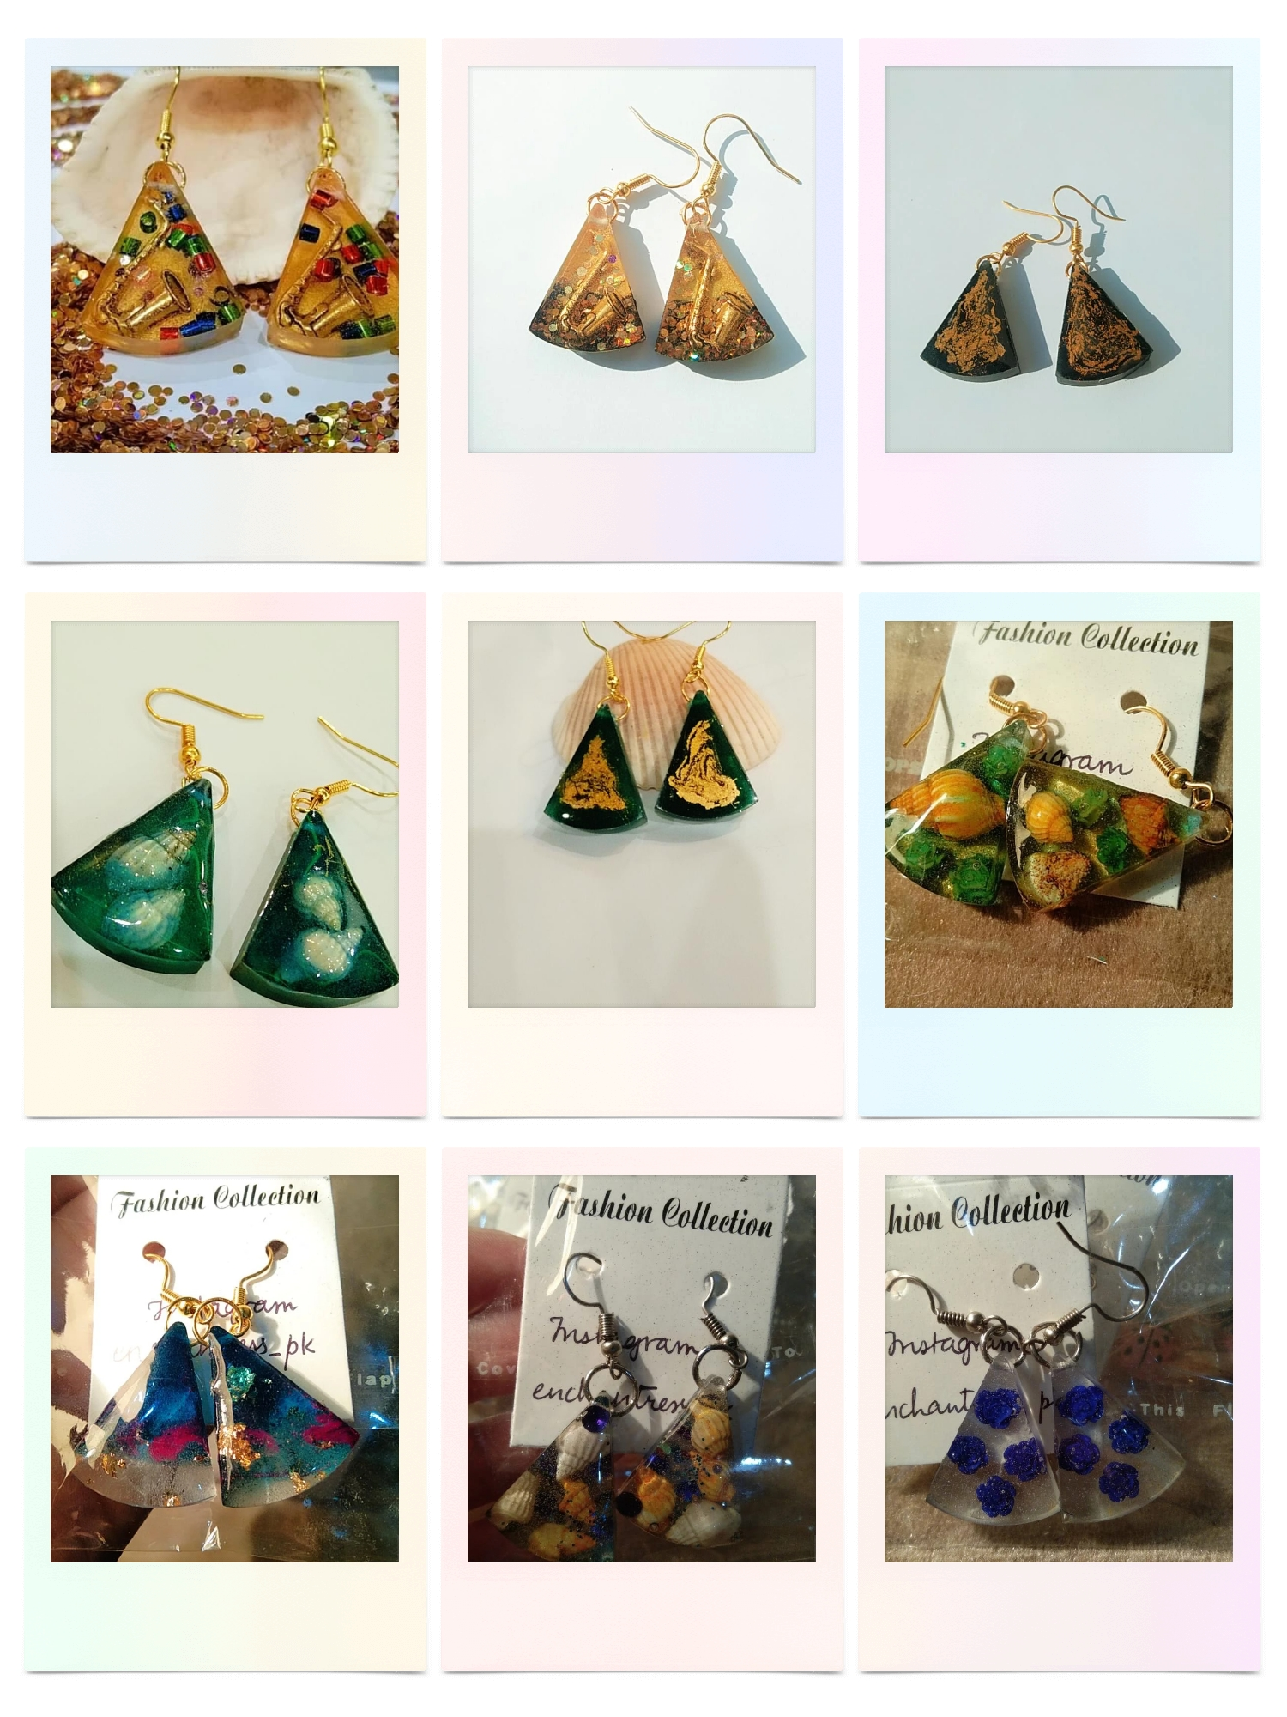
They are perfect for matching any kind of apparel.
Pendants:
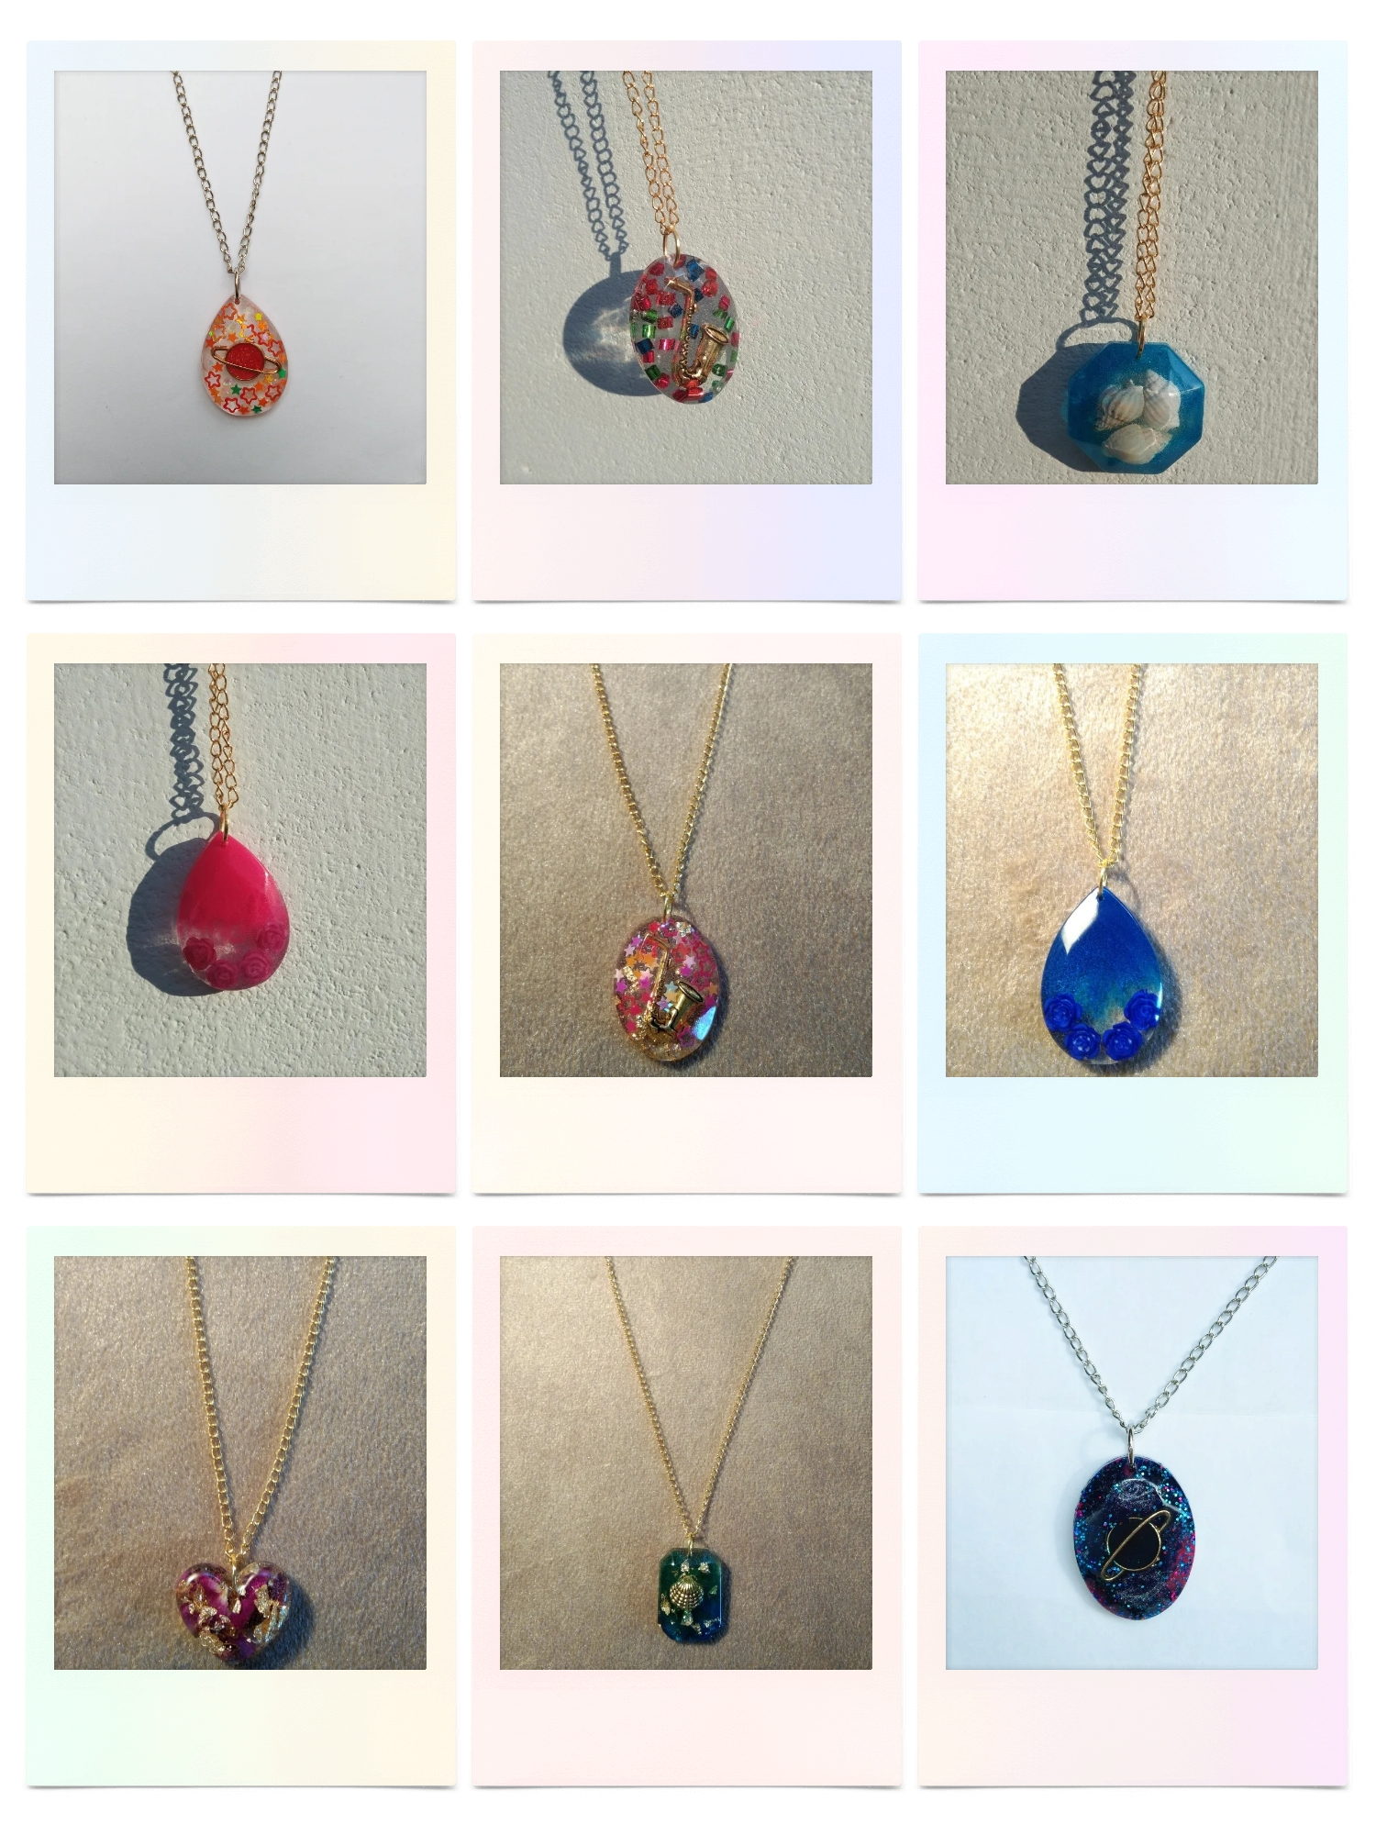
They are the best-selling product of my small-scale business. They are available in various eye-catching colors, also there is a diversity of shapes and sizes. (Droplet, rectangular, heart, oval and triangular shapes are available). You can wear it on any occasion and can match any kind of attire.
Keychains:
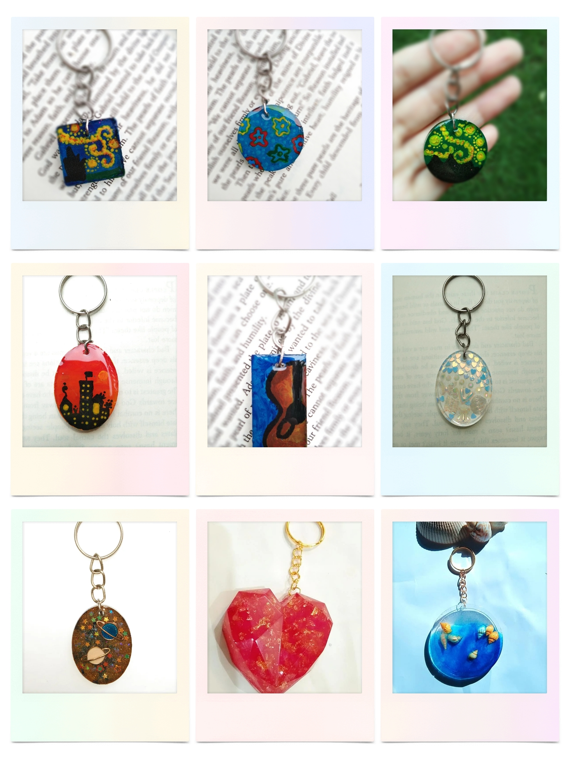
Keychains are uniquely designed and are available both in golden and silver chains. They are painted with acrylic paints. They are the best choices for gifting.
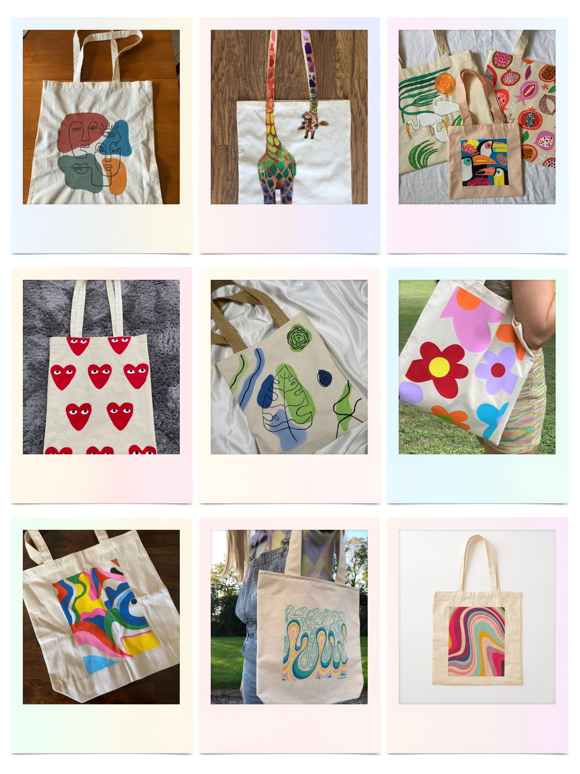
Tote bags: Tote bags are usually used in the substitute of plastic bags to maintain the sustainability of the environment. These bags are a new product line for my business. They are washable and painted with fabric paints. They are soft to the touch and is feasible for any age and gender.
Paintings:
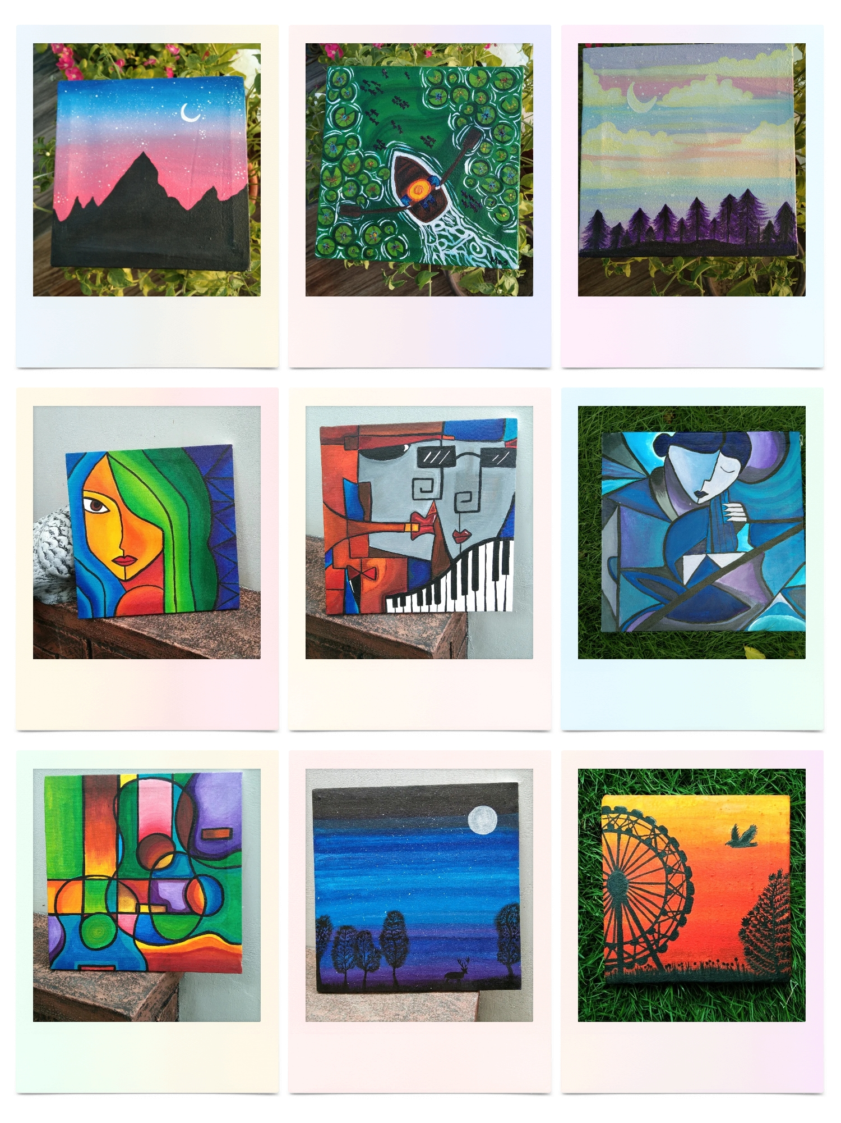
Painting is another way of keeping a diary. Paintings are usually made with acrylic paints furthermore they can give an additional appealing look to your room.

- Market Plan
Creativity and an interest in selling what you make are two key requirements for someone considering starting a resin business. As it’s not likely to be a primary source of income, you’ll devote quite a bit of your downtime to the business. Imagine spending 8 to 10 hours per week making resin art and another 4 hours per week promoting and selling your pieces. My business is based on the concept of a sole proprietorship that’s why my team includes me which is performing all the business functions accordingly.
Resin market trends are increasing day by day and there’s a favorable chance of growth in the future while maintaining my identity I can strive in the market.
A quick survey, of resin items for sale on sites like Amazon, Etsy, Poshmark, and Facebook Marketplace reveals how active the market is and how much money is being made. Many people want resin art, and high demand has driven prices up. Analysts predict that, by 2027, the resin market will generate $10.3 billion.
Since segmented marketing creates a dialogue among other young consumers, this will influence brand awareness and product preferences of other individuals as youth is an essential determinant of consumer behavior. Social media is also vitally important when marketing to young adults. Enchantress is currently present only online on the Instagram account: enchantress_pk and on Facebook Enchantress deals with ample customers happily.
Plans for Market Expansion:
- Paid PR marketing and collaborations.
- Website development.
- New product development and diversification.

V.SWOT Analysis

Strengths  - My company produces creative and attractive products that are loved by everyone.  - I have gained a strong positioning among the customers and they often regard my strong marketing.  - Good reviews from the customers. | Opportunities  - New market trends are the opportunities  - Resin market is showing a positive growth  - New fashion trends in the world are the focus of my sight that helps me to make my products according to the benchmark of every culture.
Weakness  - Delivery service still needs improvement  - I lack moulds for the various designs.  - The supplier is quite far away from my home. | Threats  - The rising prices of resin and moulds.  - Competitor using premium pricing policy.

VI. Competitor Data Collection Plan
Price | My competitor has comparatively low price ranging from 300-1100/- | I have a premium pricing policy, due to the expensive raw material. My price range is from 400-4000/-
Benefits & Features | My competitor sells pendants, alphabetical keychains, crystal pendants. | I sell tote bags, earrings, painted keychains, rare-shaped pendants, and paintings.
Market Strategy | They mostly upload stories on Instagram and WhatsApp | I usually go for posts and stories on Instagram, WhatsApp, and Facebook. Furthermore, I’ll look for future paid PR marketing.

VII.Competitive Analysis:
According to the analysis, the competitor is lacking in several areas of marketing and product making. I’ve decided that I’ll launch more related resin products for that I need to buy moulds that ranges from 600-1100 PKR. I’ll launch resin coasters, pencil holders, crystal pendants, trays, and various ornament pieces.
To maintain the uniqueness of my brand I’ve decided to launch my garments line so that it’s different from the current product line and captivates more audiences on large scale.
My business will become diverse when I’ll add new product lines like garments in the future.

Positioning:
My target audience is my target market is primarily focused on women looking for trendy accessories. My products are made keeping the youth and their artistic tastes in mind. Everyone has an obsession with following trends on social media that’s why I keep my designs that reach the benchmark of every fashion culture so that my business stands out from my competitors. Every product that I create has its own identity and uniqueness. However, Keychains and tote bags are the unique selling point of my business.
I’ve already positioned it in my customers. Most of my customers are repetitive buyers and this behavior leads to buzz marketing.
How I will market my products?
Advertising techniques that I’ve used up now
- Distribution of various pamphlets, brochures, and business cards at my university.
- Social media marketing videos and posts on Instagram and Facebook.
- Videography
- Word of mouth
My plans for the future marketing
- Website development
- Paid PR marketing by Instagram promotion
- Search engine optimization
- Networking.
- Content marketing and PR.
Promotional Budget
Before starting up my business I didn’t use the influencer marketing strategy. The fundamental mission was to inaugurate my product, As my business is developing it needs some sort of PR collaboration and influencer marketing so that the main aim of the higher audience is accomplished. I haven’t invested in marketing, it’s mostly done through word of mouth.
VIII.Marketing Expenses Strategy Chart
Current expense | None
Expected future budget | PKR 9450/- over a month reaching (2700-7200) accounts

IX.Operational Plan
Production:
My products are handmade so I’m the sole manufacturer and seller of my product. I use the delivery service of leopards and bikea which is easy to use and they both provide the feasibility of cash on delivery.
Quality Control:
My products are loved by every customer dearly but I’m constantly working on the improvement of my products and packaging. My plans for packaging are elegant paper boxes with a thank you letter in them.
Inventory:
My inventory consists of raw materials and finished goods. It depends upon the intensity of the orders.
Suppliers:
My current suppliers are whole sale raw material suppliers.

X. Financial Plan
Initial investment: 7500/-
Total revenue : 20000/-+
Growth rate is positive
- To increase sales and audience engagement investment is required.
- Investment required: 50000/- including all paid PR collaborations, packaging , resin moulds and other raw materials.

