Mechanism of Cardiac Muscle Contraction

Learning Objectives

At the end of the tutorial, the student should be able to:

Describe the Specialized Excitatory and Conductive System of the Heart?

Define what is primary pace maker?

Clarify the function of internodal pathways?

Explain what are purkinji Fibers?

Define a cardiac myocyte?

Explain the Excitation and Contraction of Cardiac Myocyte.

Show the role of gap Junctions?

Cardiac muscle contraction

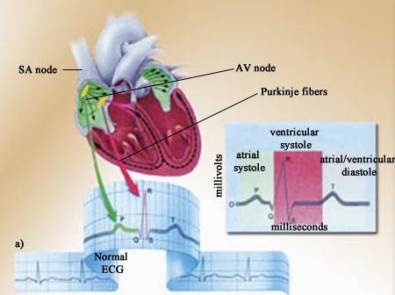
Heart is endowed with a special system for generating rhythmical electrical impulses to cause rhythmical contraction of heart muscle and conducting these impulses rapidly through heart.

Atria contract about one sixth of a second ahead of ventricular contraction, which allows filling of ventricles before they pump blood through lungs and peripheral circulation.

Specialized Excitatory and Conductive System of the Heart.
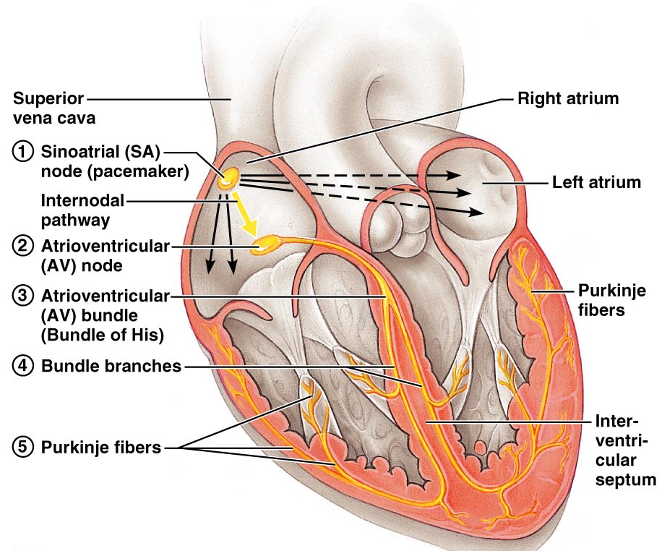

Controls cardiac contractions.

Shows the sinus node (Also called sinoatrial or S-A node).

The internodal pathways.

The a-v node.

The a-v bundle.

Left and right bundle branches of purkinje fibers.

Normal rhythmical impulse is generated in S-A node, therefore called the primary pacemaker.

Internodal pathways conduct impulse from the sinus node to the atrioventricular (A-V) node;

The impulse from the atria is delayed in A-V node, before passing into the ventricles;

A-V bundle conducts Impulse from the atria into ventricles;

Left and right bundle branches of purkinje fibers, conduct the cardiac impulse to all parts of ventricles.

Sinus (Sinoatrial) Node
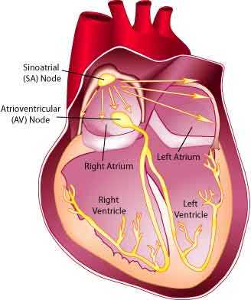

Fibers of this node have almost no contractile muscle filaments.

However, the sinus nodal fibers connect directly with the atrial muscle fibers, so that any action potential that begins in the sinus node spreads immediately into the atrial muscle wall.

Purkinje Cells
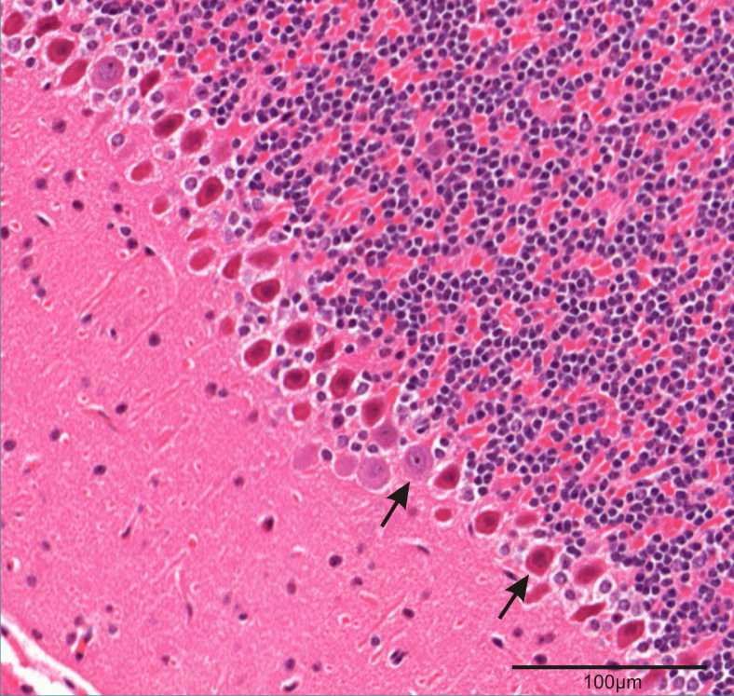

Larger than ordinary cardiac fibers and bundle fibers

Conduct action potentials four times faster than a ventricular myocyte (4m/sec)

May be binucleate

Few myofibrils

Vacuous cytoplasm (filled with glycogen)

Subendocardial location

Linked to cardiac fibers and bundle fibers by gap junctions and desmosomes.

Excitation and Contraction of Cardiac Myocyte

Cardiac Myocyte

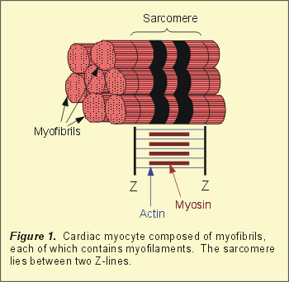
Inside each cardiomyocyte are hundreds of myofibrils which are thin, elongated structures.

Each myofibril, in turn, consists of thin and thick filaments.

Each thin filaments is composed of a protein called actin.

Each thick filaments is composed of a protein called myosin.

Each myosin filament is composed of about 200 myosin molecules.

Each myosin molecule contains what is called a myosin head.

Inside each cardiomyocyte there are compartments filled with calcium.

The action potential causes these compartments to release the calcium into the cell.

This calcium allows myosin heads to bind to actin filaments and pull them by a process called a power stroke.

That is how action potential causes the individual muscle cells to contract.

Gap Junctions

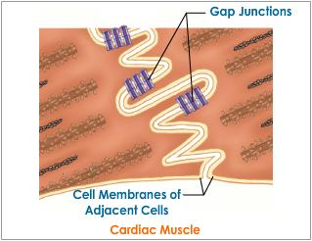
Low resistance connections

Small pores in the center of each gap junction

Allows ions and small peptides to flow from one cell to another

Action potential is propagated to adjacent muscle cells.

AN ION INSIDE A SA NODAL CELL COULD TRAVEL THROUGHOUT THE HEART VIA THE GAP JUNCTIONS.

Sarcomere

Basic contractile unit within the myocyte.

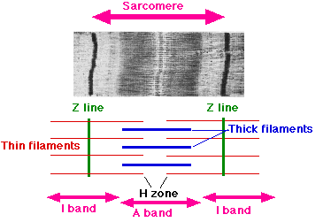
Refers to the unit from one Z band to the next

Resting length: 1.8-2.4 m.

Composed of interdigitating filaments:

Thick myosin protein.

Thin actin protein.

Sarcolemma
(sarco = flesh; lemma = thin husk)

Each cell is bounded by a complex cell membrane.

Composed of a lipid bilayer

Hydrophilic heads

Hydrophobic tails.

Impermeable to charged molecules (barrier for diffusion).

Contains membrane proteins, which include receptors, pumps and channels.

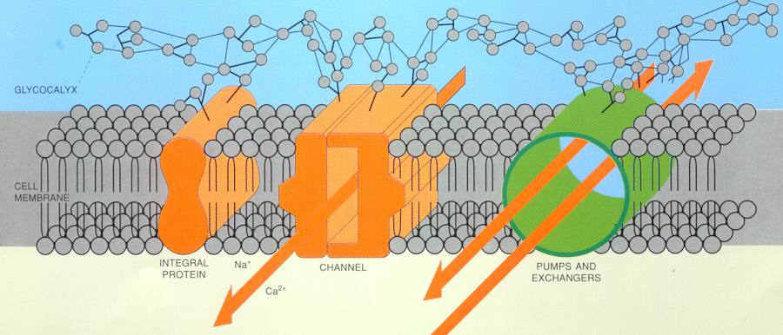
Sarcolemma contains a number of ion channels and pumps that contribute to overall Ca 2+ levels within the myocyte

Transverse Tubular System (T-tubules)

The sarcolemma of the myocyte invaginates to form an extensive tubular network

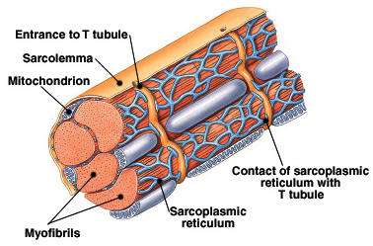
Extends the extracellular space into the interior of the cell.

Transmit the electrical stimulus rapidly (well developed in ventricular myocytes but is scanty in atrial and purkinje cells).

Mitochondria
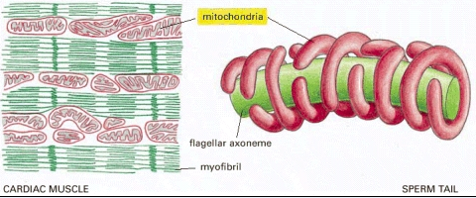

Generate the energy in the form of adenosine triphosphate (ATP).

Maintain the heart’s contractile function and the associated ion gradients.

Sarcoplasmic Reticulum (SR):

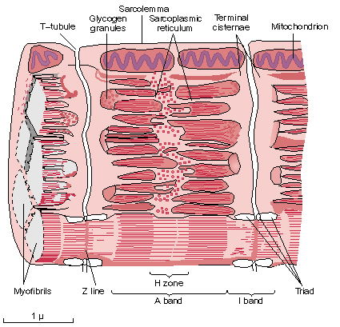
A fine network spreading throughout the myocytes.

Demarcated by its lipid bilayer.

Close apposition to the T tubules.

Junctional SR.

Longitudinal SR.

Subsarcolemmal Cisternae
Junctional SR:

The tubules of the SR expand into bulbous swellings.

Contains a store of ca²⁺ ions.

Release calcium from the calcium release channel (ryanodine receptor) to initiate the contractile cycle.

Longitudinal or Network SR:

Consists of ramifying tubules.

Concerned with the uptake of calcium that initiates relaxation.

Achieved by the ATP-requiring calcium pump (SERCA= sarcoendoplasmic reticulum Ca²⁺ -ATPase)

References

Text book of Medical Physiology – Eleventh Edition. GUYTON AND HALL.

Color Atlas of Physiology - 6th Edition. Thieme_2008.

